## Vascular resistance

**Vascular resistance** is the resistance to flow that must be overcome to push [blood](https://en.wikipedia.org/wiki/Blood) through the [circulatory system](https://en.wikipedia.org/wiki/Circulatory_system). The resistance offered by the peripheral circulation is known as the **systemic vascular resistance** (**SVR**).

[Vasoconstriction](https://en.wikipedia.org/wiki/Vasoconstriction) (i.e., decrease in blood vessel diameter) increases SVR, whereas [vasodilation](https://en.wikipedia.org/wiki/Vasodilation) (increase in diameter) decreases SVR.

The basic tenet of calculating resistance is that flow is equal to driving pressure divided by resistance.

Resistance to blood flow within a vascular network is determined by the size of individual vessels ([length and diameter](http://www.cvphysiology.com/Hemodynamics/H003.htm)), the organization of the vascular network ([series and parallel](http://www.cvphysiology.com/Hemodynamics/H004.htm) arrangements), physical characteristics of the blood ([viscosity](http://www.cvphysiology.com/Hemodynamics/H011.htm), [laminar](http://www.cvphysiology.com/Hemodynamics/H006.htm) flow versus [turbulent flow](http://www.cvphysiology.com/Hemodynamics/H007.htm)), and extravascular [mechanical forces](http://www.cvphysiology.com/Blood%20Flow/BF001.htm) acting upon the vasculature.

Of the above factors, changes in vessel [diameter](http://www.cvphysiology.com/Hemodynamics/H003.htm) are most important quantitatively for regulating blood flow within an organ, as well as for regulating [arterial pressure](http://www.cvphysiology.com/Blood%20Pressure/BP002.htm). Changes in vessel diameter, particularly in [small arteries](http://www.cvphysiology.com/Blood%20Pressure/BP019.htm) and [arterioles](http://www.cvphysiology.com/Blood%20Pressure/BP019.htm), enable organs to adjust their own blood flow to meet the metabolic requirements of the tissue. Therefore, if an organ needs to adjust its blood flow (and therefore, [oxygen delivery](http://www.cvphysiology.com/CAD/CAD002.htm)), cells surrounding these blood vessels release [vasoactive substances](http://www.cvphysiology.com/Blood%20Flow/BF002.htm) that can either constrict or dilate the [resistance vessels](http://www.cvphysiology.com/Blood%20Pressure/BP019.htm).

**Constants**

**133.322 Pa/mmHg**

**13.595 mmH20/mmHg**

### Hepatic pressures

**Hepatic artery**

**PHA=100 mmHg** {Rappaport1979}

**Portal vein**

The normal blood pressure within the portal vein is around 5 to 10 mmHg.

mesenteric vein:

**PPV** =127±1.1mmH2O = **9.34±0.70 mmHg** {Nakata1960} (rat liver, N=7)

**PPV** ~120mmH2O = **8.83 mmHg** {Nakata1960} (previous reports, rat)

Large pressure drop in the portal venous tree to portal venules (130mmH2O to 60mmH2O) and significant pressure drop between portal venules and central veins.

About half of the portal venous pressure is dissipated in passage from the major extrahepatic branches of the portal vein to the terminal distributing radicals

portal vein at liver hilum:

**PPV** ~109.6±3.0 mmH2O = **7.86±0.22 mmHg** (±SE, N=10, normal rat) {Shibayama1985}

**Portal venules**

**Pa** = 50 mmH20 = **3.68 mmHg** {Rappaport1979}

Extralobular portal venule (needle at right angles to bloodstream, diameter vessels of 30-40µm):

**Pa** = 63±2 mmH20 = **4.63±0.15 mmHg** {Nakata1960} (rat liver, N=7)

terminal portal venule

**Pa** = 68.1±1.0 mmH20 = **5.01±0.07 mmHg** (±SE, N=10, normal rat) {Shibayama1985}

**Central venules**

**PCV** = 10 mmH20 = **0.74 mmHg** {Rappaport1979}

Hepatic venules (smallest collecting branches, diameter ranging from 40-60µm):

**PCV** = 23±1.5 mmH20 = **1.69±0.11mmHg** {Nakata1960} (rat liver, N=7)

Terminal hepatic venule:

**PCV** = 27.5±1.2 mmH20 = **2.02±0.09 mmHg** (±SE, N=10, normal rat) {Shibayama1985}

**inferior vena cava**

**PCV** = 20.3±1.0 mmH20 = **1.49±0.07 mmHg** (±SE, N=10, normal rat) {Shibayama1985}

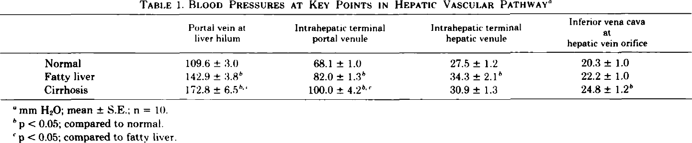

{Shibayama1985}

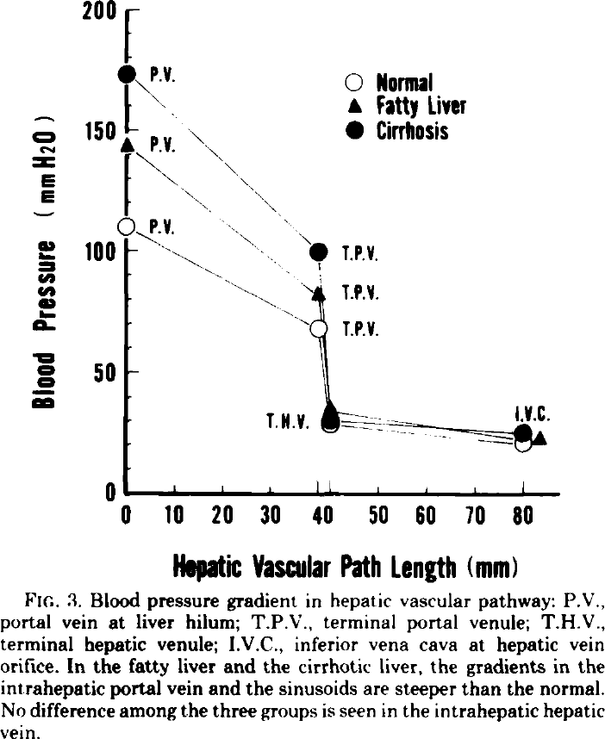 {Shibayama1985}

Increase in vascular resistance in cirrhotic liver is present in the intrahepatic portal vein and sinusoids, but not in intrahepatic hepatic vein {Shibayama1985}.

It is suggested that increase in vascular resistance in intrahepatic vein and sinusoids correlate with these structural changes {Shibayama1985}.

An increase in blood pressure difference between two given points means an increase in vascular resistance at an intermediary site, unless the blood flow increases {Shibayama1985}.

Transillumination observations confirm other experiments indicating extraordinary sensitivity of the hepatic parenchyma to elevations in venous pressure (even when venous pressures where by no more than 10mmH2O=0.74mmHg) {Nakata1960}

**Hepatic resistance**

The resistance of th e HA bed is around 30-40 times that of the portal venous bed {Rappaport}

# see [Rappaport -> 161]

# portal pressure depends primarily on the state of constriction or

# dilatation of the mesenteric and splenic arterioles and on the

# intrahepatic resistance.

Normal hepatic arterial pressure is already greatly reduced within the sinusoids and has little influence on the portal pressure [Rappaport -> 264,265]

Presinusoidal & sinusoidal portal hypertension also occur depending on the the site of hindrance factor [Rappaport 286 -> hepatic venous pressure]

Systemic vascular resistance

70-160 MPa*s/m^3

9-20 mmHg*min/l

### Viscosity

Blood viscosity is the intrinsic resistance of blood to flow in vessels. Its major determinants are: the volume fraction of red blood cells (haematocrit); plasma viscosity (which is determined mainly by plasma fibrinogen, other biologically reactant globulins, and lipoproteins); red cell deformation (under high flow/shear conditions); and red cell aggregation (under low flow/shear conditions) {Lowe1996}

Blood viscosity is defined as the inherent resistance of blood to flow. Normal adult blood viscosity is 40/100, which is read as “forty over one hundred” and reported in units of millipoise.

Blood is a vigorous organ insofar as it behaves as a non-Newtonian fluid, which means that its viscosity changes as a function of shear rate. Think of shear rate as velocity. When blood moves quickly as in peak-systole, it is physically thinner; when it moves slowly during end-diastole, it is thicker and stickier. This is because red cells aggregate. The phenomenon is known as the shear-thinning, non-Newtonian behavior of whole blood [2].

35 millipoise (mP), depicting a Newtonian fluid, and the blue line is the viscosity of water at 10 mP.

1 Poise = 1 Pa*s

* 10-30 mP = mPa*s

0.010-0.030P

1 centiPoise = 1mPa*s

Viscosicty blood as Newton fluid ~ 35 mP

Viscosity was measured at high shear rates (over 300/s) in viscometer at 37°C

Blood viscosity: 3.5-3.7 mPa*s {Lowe1996}

Plasma viscosity: 1.35 mPa*s {Lowe1996}

Viscosity is substantially greater in whole blood or plasma not yet treated with anticoagulants

Plasma viscosity: 1.8 mPa*s {Wells1961}

Blood viscosity: 8.4-7.3cP= 8.4-7.3 mPa*s {Wells1961} (haematocrit 44, shear rate 23-46 1/sec)

Blood viscosity flow dependent, with ~ *3 at v=100µm/s

=> 10 mPa*s

## References

<https://en.wikipedia.org/wiki/Vascular_resistance>

<http://www.cvphysiology.com/Hemodynamics/H002.htm>

Rappaport, AM. "Hepatic blood flow: morphologic aspects and physiologic regulation." *International review of physiology* 21 (1979): 1-63.

Nakata, K, GF Leong, and RW Brauer. "Direct measurement of blood pressures in minute vessels of the liver." *American Journal of Physiology--Legacy Content* 199.6 (1960): 1181-1188.

Nakata, Katsuji. "Microcirculation and hemodynamical analysis of the blood circulation in the liver." *Pathology International* 17.3 (1967): 361-376.

Shibayama, Yuro, and Katsuji Nakata. "Localization of increased hepatic vascular resistance in liver cirrhosis." *Hepatology* 5.4 (1985): 643-648.

Rappaport, AM et al. "Hepatic microcirculatory changes leading to portal hypertension." *Annals of the New York Academy of Sciences* 170.1 (1970): 48-65.

Rappaport, AM. "The microcirculatory hepatic unit." *Microvascular research* 6.2 (1973): 212-228.

MacLeod, JJRs, and RG Pearce. "The outflow of blood from the liver as affected by variations in the condition of the portal vein and hepatic artery." *Am. J. Physiol* 35 (1914): 87.

Ternberg, Jessie L, and Harvey R Butcher. "Blood-flow relation between hepatic artery and portal vein." *Science* 150.3699 (1965): 1030-1031.

Lowe, GDO et al. "Blood viscosity and risk of cardiovascular events: the Edinburgh Artery Study." *British journal of haematology* 96.1 (1997): 168-173.

Secomb, TW. "Flow-dependent rheological properties of blood in capillaries." *Microvascular research* 34.1 (1987): 46-58.